Visit of Director Planning Higher Education Department

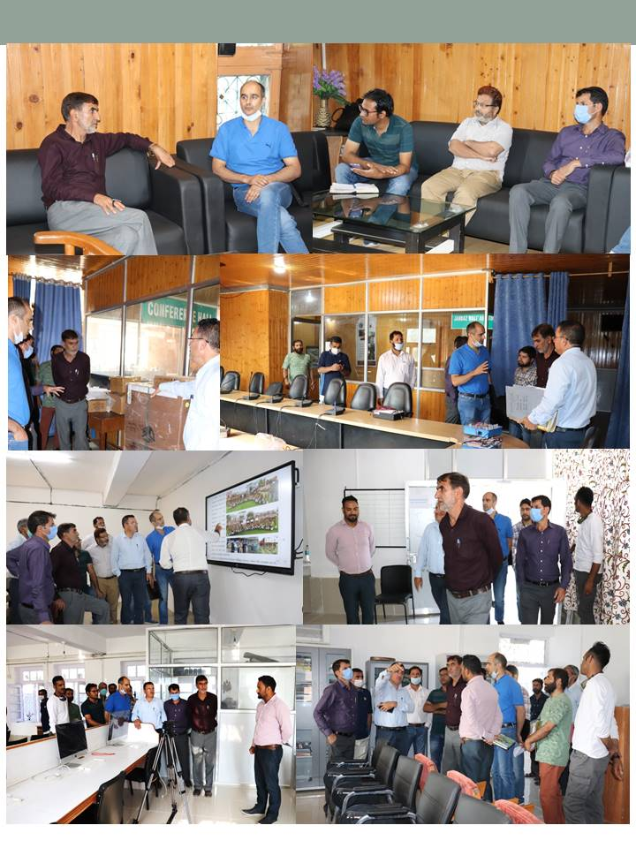
Director Planning Higher Education dept. inspecting Physical progress of works
On the directions of Worthy Secretary to Govt. department of Higher Education, a team from Administrative department visited college on 25th August 2021 to take stock of CAPEX budget 2021. The team headed by Director Planning Higher Education inspected various on-going works being executed by agencies like R and B (PWD) Baramulla, and J&K Small Scale Industries Development Corporation Limited (SICOP) Srinagar in the college campus. The team also took stock of various procurements in components like equipments in Food technology and fruit processing, Media centre, Computer Applications, Browsing centres. The director also inspected physical progress of works being undertaken under RUSA 2.0 infrastructural grant scheme like construction of Conference Hall, up-gradation works etc.
During the visit the Director expressed satisfaction with the progress of works under various schemes of CAPEX budget 2021 and was all praise for Principal of college Prof.(Dr.) M.A.Lone for executing the works in a time bound manner following all codal formalities. Director also expressed gratitude to executing agencies and acknowledged their role for timely execution of works.
The director was briefed about all components of CAPEX budget by Team IQAC and Convenor Purchase Committee.

